What is server? Computer in London can talk to computer in Seattle. There are some one of special computers are online 24/7 ready to serve you all the data and files you are requesting. Computers are doing that called server. Computers that any user could use, called client.

Image a web server as a gaint library that open 24/7, you can go in there any hour of the day and request, like you wanna see Google's homepage.

You can image if the library that is big enough to house these websites. It's gonna be difficult to quickly locate the thing you want out of this gaint library.

How to solve this problem?

Let’s say that you are going to type google.com. Your browser will send a message to your internet service provider (ISP) *“is an organization that provides services for accessing, using, or participating in the Internet. ISPs can be organized in various forms, such as commercial, community-owned, non-profit, or otherwise privately owned,”* Like Xfinity, AT&T, or starlink etc.

ISP will replay the message to DNS server, Domain name system server, it is like phonebook. “*When users type domain names such as ‘google.com’ or ‘nytimes.com’ into web browsers, DNS is* ***responsible*** *for finding the* ***correct IP address*** *for those sites.* ***Browsers then use those addresses to communicate with origin servers*** *or CDN edge servers to access website information. This all happens thanks to DNS servers: machines dedicated to answering DNS queries.”*

Every single computer that’s connected to the internet has an IP address, like postal/zip code for your computer. Each computer can be located by their unique IP address.

Once the DNS server finds the IP address (the thing you are looking for), it sends that back to your browser, now you know exact address where you can find the Google homepage. Next thing that happens is you will send a direct request to that address. This message will be delivered by ISP (wifi company) via internet backbone. **The submarine cable**

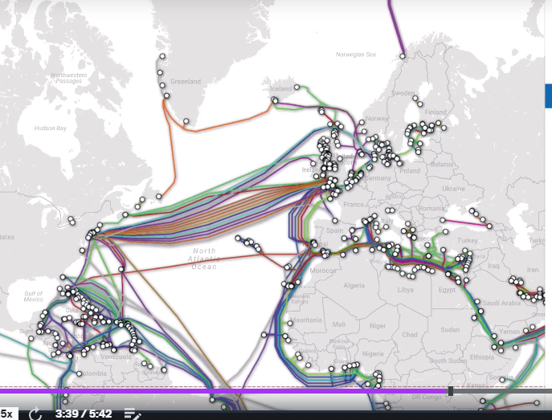

If I’m in Seattle that I want to visit a website hosted in China, my browser would have to make a request that goes through one of the cables. It’s like as if I’m sending a letter across the world, the only hope for my letter to reach my friend is that postal address/zip code/IP address on the letter.



Once I got the IP address of the website, the my browser sends another message through the internet service provider (ISP, wifi) via internet backbone to the server that is located at address xxx.xx.xxx.xx.

The computer that is located at that address is the “Google server”, or the server of that “website” you want to reach. On the server, all the files that I need in order to view the Google homepage. The server sends all those files back to me through the internet backbone. Then I get to see the Google homepage on my browser.

